Travel & Tourism Management System

INFO- 6050 CAPstone Test Strategy

Amendment History:
Version | Date | Amendment History
V 1.1 | 25/01/2016
V 1,2 | 19/03/2016

Reviewers:
This document must be reviewed by the following:
Name | Signature | Title / Responsibility | Date | Version
Dr. Arif Raza |  | Client | 25/01/2016

Approvals:
This document must be approved by the following:
Name | Signature | Title / Responsibility | Date | Version
Dr. Arif Raza |  | Client | 25/01/2016

Distribution:

Related Documents:
These documents will provide additional information.
Ref no | Doc Reference Number | Title | Version
1.0 | 001 | Project Plan | 1.3

Glossary of Terms:
List any terms used in this document.
Term | Acronym | Definition

No Such terms used.

Table of Contents
Table of Contents 3
1. Introduction 4
1.1. Objectives 4
1.2. Scope 4
2. Testing Overview 4
2.1. Test Lifecycle 4
2.2. Test Approach 4
2.3. Standards 4
2.4. Test Stages 4
2.5. Reviews and Inspections 5
2.6. Test Documentation 5
2.7. Test Execution 6
2.8. Entry & Exit Criteria 6
2.9. Test Results Capture 6
2.10. Progress Reporting 7
3. Test Data 7
4. Testing Environments 7
4.1. Specification 7
5. Testing Tools 7
5.1. Test Management Tools 7
5.2. Test Automation Tools 7

Introduction

Objectives
This is a test strategy document for a project named of “Travel & Tourism Management System”. This document would be used and completed by the project team “Iconoclast”. The testing effort would be decided on the basis of the requirements and priorities of the project. This is a live document which would be updated as the project testing progresses. The final version of the test strategy document would be approved by project manager and other team members.

Scope
The test strategy for the project “Travel & Tourism Management System” would cover the functional testing as well as the non-functional testing. The team would follow a testing lifecycle and would carry out continuous reviews and inspections. The test results would be captured and documented to the developing team. Various testing tools would be used to test the application. The team would also use test management and test automation tools. Installation of the application would be tested on various platforms.

Testing Overview

Test Lifecycle
Testing lifecycle plays an important role in guiding the team on how and when to execute the tests. As mentioned in previous meetings with the client that the testing team would be using the agile methodology. Testing in Agile has to work with the lifecycle adopted by the team. We would be using Test Driven Development as an Agile Testing approach. In agile, testing is focused on unit testing and acceptance testing while the integration and regression testing are done on daily basis by automation.
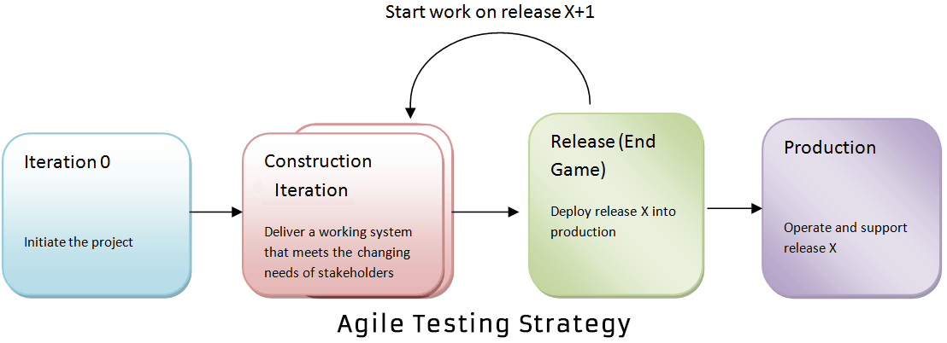

REFERENCE

In agile testing, testing is carried out in every iteration of agile cycle.
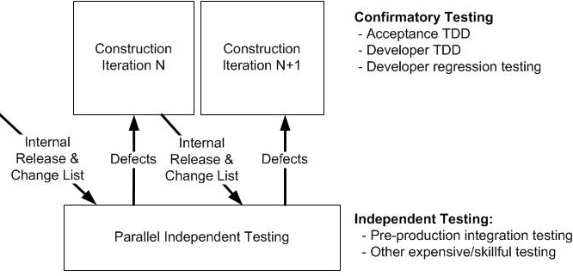

REFERENCE

Test Approach
Testing would be carried out in such a way which would encompass all the functionalities of the project “Tourism & Travel Management System”. The team would carry out functional and non-functional testing. Team would carry out unit, assembly, system, usability, load, performance, regression, installation/ configuration testing and also would verify the documents created during this period.

Standards
Below are the listed standards which we are considering,
- ISO/IEEE 29119,The International Software Testing Standard for test processes, test documentation and test techniques.
- IEEE 829, Test Documentations.

Test Stages
A coverage matrix of all the Test Stages / Test Areas to be covered in each Test Release is appended below

Unit Testing: It is the level of testing where individual components/units of a software are tested.

Integration Testing: Individual software modules are integrated logically and tested as a group.

System Testing: This is a testing of a fully complete and integrated software product.

Acceptance Testing: Type of testing done by client to certify the system with respect to the requirements that was agreed upon.

Test Areas/ Test Type | Unit Testing | Integration Testing | System Testing | Acceptance Testing
Functional | 
Non-Functional

Business Processes

Volume

Performance

Security (including Penetration Testing)

Data Protection

Usability

Interface Tests

Installation & Configuration

Systems & Service Management & Service Level Reporting

Disaster Recovery

Smoke Testing

Reviews

Reviews

Versions | Date | Name | Role/Position | Sign Off | Comments
V 1.1 | 25/01/2016 | Dr. Arif Raza | Client
V 1.1 | 25/01/2016 | Prof. Arif Raza | Professor/Test Manager
V 1.2 | 19/03/2016 | Dr. Arif Raza | Client
V 1.2 | 19/03/2016 | Prof. Arif Raza | Professor/Test Manager

Test Documentation
Below the table shows all the documents with its related phases of testing cycle to make the testing runs smoothly.

Document | Phase and cycle
Test Strategy | Planning and Analysis Phase
Test Plans | Test Design Phase
Test Specifications/Test Cases | Test Environment setup/Implementation Phase
Test Scripts | Test Execution Phase
Test Report | Conclusion/Reporting Phase

Test Execution
- Test will be executed on the basis of the test case, test specification document and test script designed before the test execution
- Environment for test execution: Eclipse framework with Tomcat Server
My Sql Database
- Test will be executed on team members laptop in the lab located at R1019

Recording Actual Results versus Expected Results

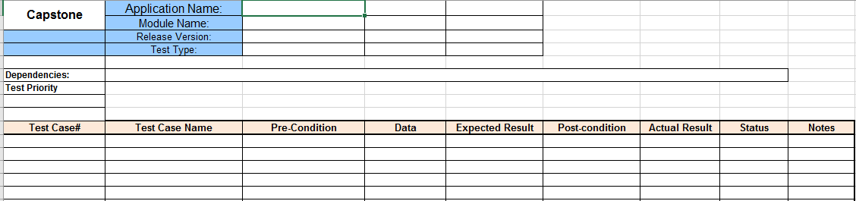
The screen shot shows the template we are going to use for recording actual results and expected results given by client.

Escalation of Issues for resolution
We have no such issues at this point

Test Execution Roles
Roles | Name
Test Manager | Omkar Bapat
Test Lead / Scribe | Yesha Modi
Usability Test Engineer | Mansi Patel
Manual Test Engineer | Manjindar Kaur
Automated Test Engineer | Yesha Modi
Security Test Engineer | Harpreet Kaur

Entry & Exit Criteria

Table of Entry and Exit Criteria
Serial No | Item Description
Entry Criteria
1. | Sign off Test Strategy
2. | Sign off Test Plan
Activities Performed
1. | Environment Setup is complete and ready to use
2. | Hardware platforms have been installed properly and configured
3. | Software tools are also configured and functioning properly
Activities to be Performed
1. | Manual test cases are prepared
2. | Automation test scripting is prepared
Exit Criteria
1. | All test cases are executed
2. | No critical bugs are left.
3. | All application functionalities are working properly
4. | All the test execution results are documented properly
5. | All software activities are completed on schedule and in predefined cost

Test Results Capture
The results of executed test cases will be captured on in MS Excel sheet.
1. Test Id
2. Test Name
3. Test Objective
4. Test Description
5. Test Data
6. Expected Results
7. Actual Results
8. Status
Any divergence between the expected and actual results will be investigated by the testing team and an associated Test Issue will be recorded in IAD logs and version controlling tool will be using such as GitHub.

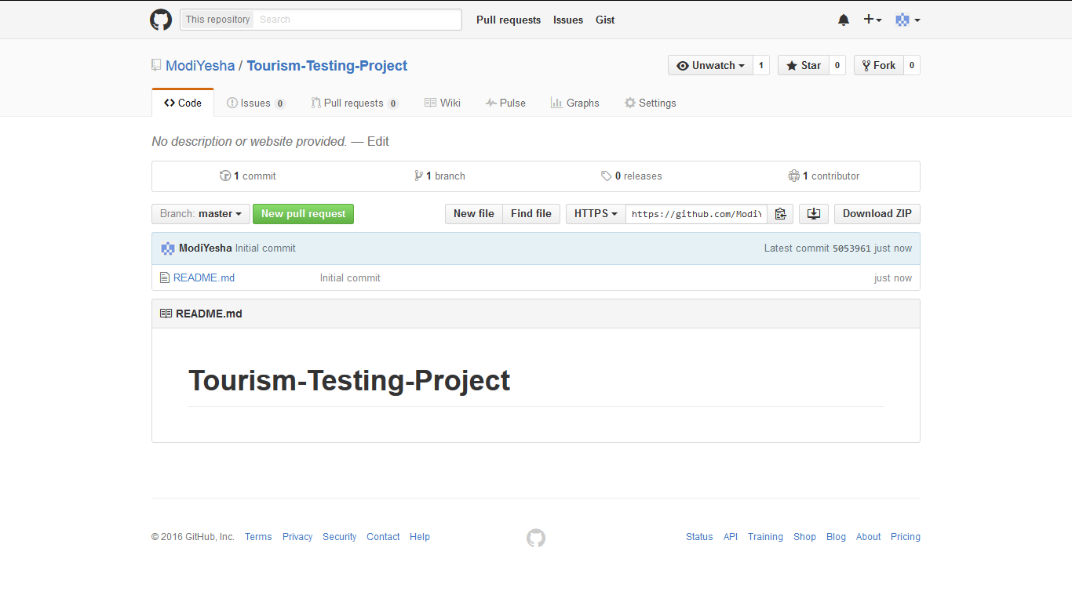

Progress Reporting

Test Report
The Agile test report will be presented using MS Office tools such as MS word, MS Excel and MS presentation. It will include the following points.

- Introduction
- Overview
- Variance
- Assessment
- Results
- Evaluation
- Summary of Activities

Test Data
To generate test data we are going to use Datamaker to create different types of test data for each test type.

Test Type | Source of Test Data
Unit Testing | Random Test Data Generator
Integration Testing | Pathwise Data Generator
Acceptance testing | Goal Oriented Generators
System testing | Intelligent Test Data Generators

Specification

Identification of the physical components, the communications, the system and middleware necessary

Operating System | Windows
Technology | Java and J2EE
Web Technologies | Html , JavaScript , CSS
IDE | My Eclipse
Web Server | Tomcat
Database | MySql5.0
Java Version | J2SDK1.5
Development Tool Kit | Development Tool Kit
Physical Components
Platform and device | Laptops
Communications | Physical Meeting with client and team members on every week.

Other software or supplies needed to support testing
Automated Testing Tool:
Junit testing

Security and access requirements to the test area and equipment
Only authorized users will be allowed to access system data
- User Login access
- Database login access

Test tools and utilities required
1. Backup Software
2. Anti - Virus
3. Network Utilities

Testing Tools

Test Management Tools

Operating System | Windows
Web Technologies | J2EE, JRE
Web Server | TomCat 8.0
Test Automation tool | Selenium
Applications | Tourism and Travel Management System
Database | MySQL
Development Tool Kit | Eclipse

Test Automation Tools
Selenium:
It is open source automation testing tool that supports rapid development of web applications.

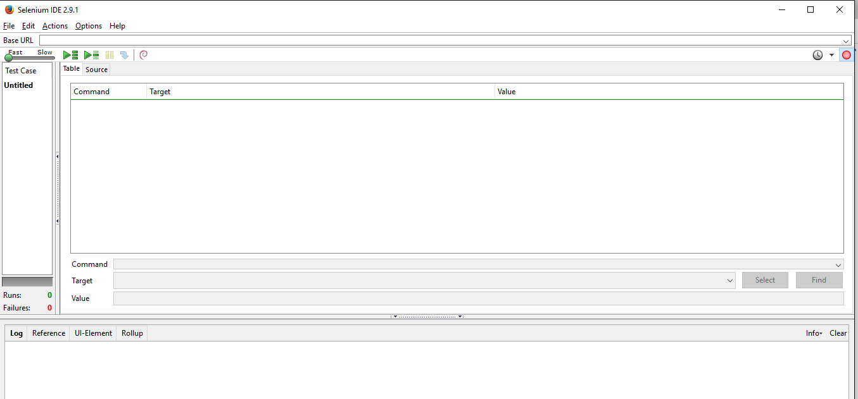
Selenium IDE
http://www.seleniumhq.org/docs/

Features:
1. It allows scripting in different languages like Java, PHP, C# and Python.
2. Tests can be run on multiple browsers.
3. Assertion statements provide the efficient way of comparing actual results with expected results.
4. It also has the inbuilt reporting mechanism.

Components:
1. Selenium IDE
2. Selenium Remote Control
3. Selenium Grid
4. Selenium Webdriver

5.Project Plan:

Using MS Project, we have created project plan with major tasks and subtasks listed below.

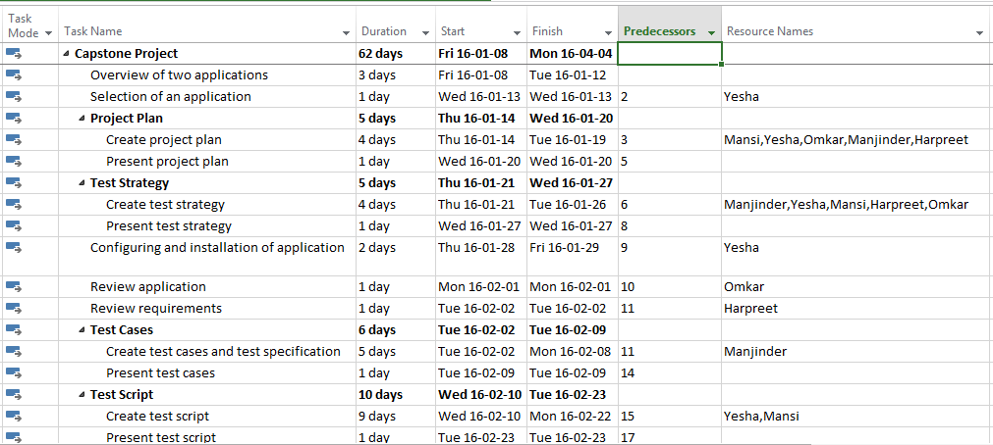
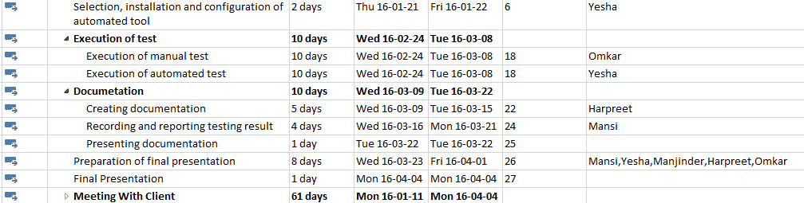
Figure 5.1: Project plan tasks and subtasks

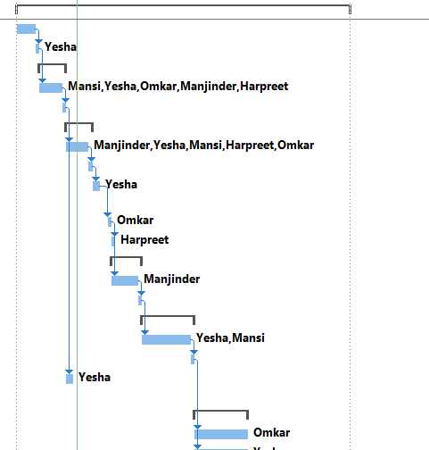
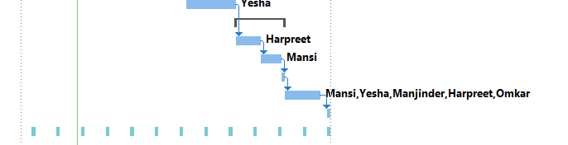
Figure 5.2 Gantt Chart representation with resource allocation

